Make access key and authenticate container

This is continue task 5 from Exercises: Deployment to Cloud

Step 3

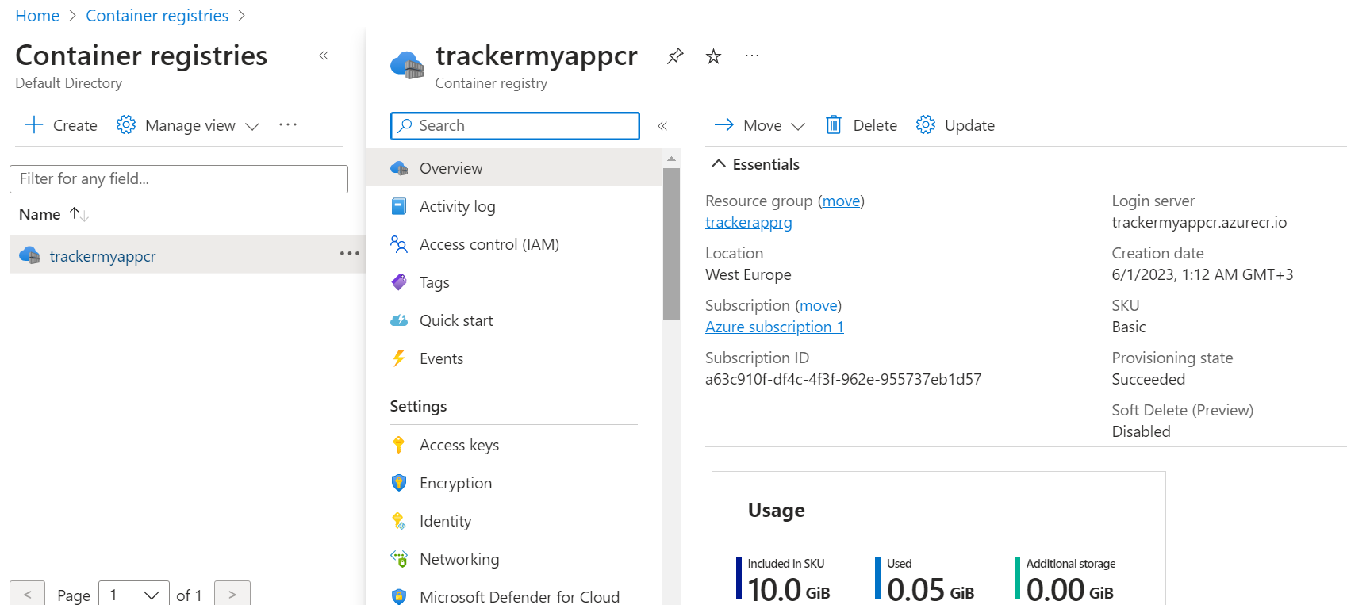

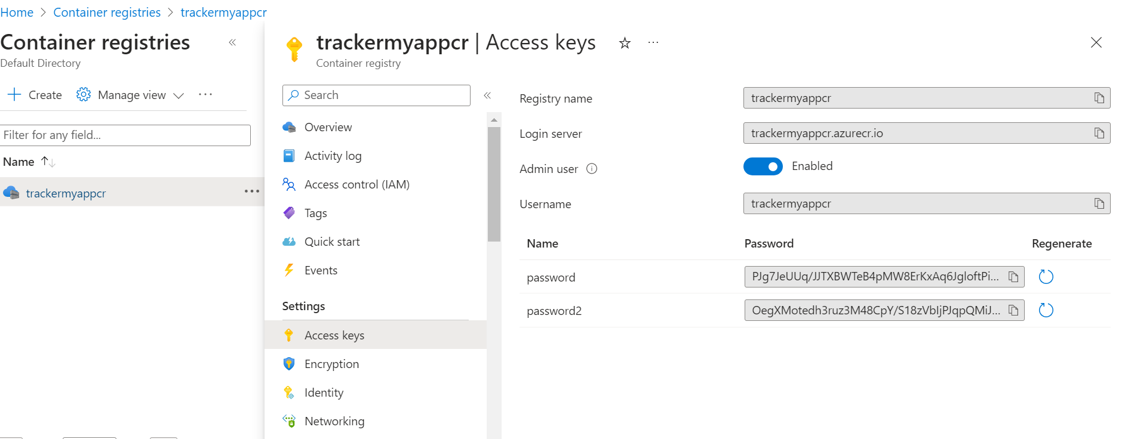

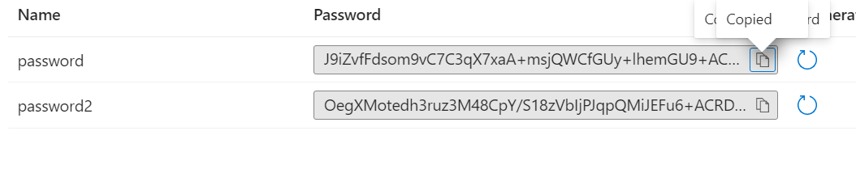

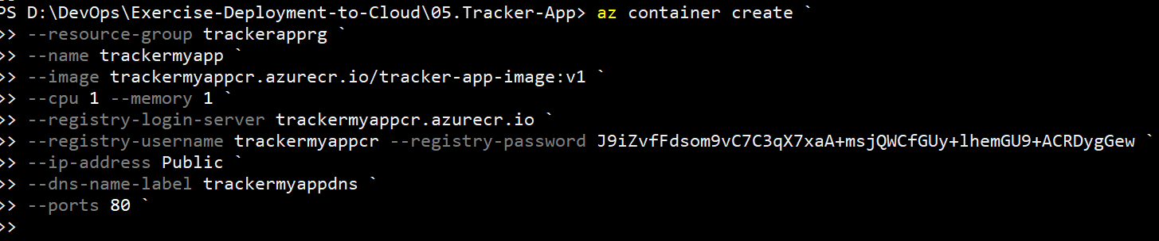

PS D:\DevOps\Exercise-Deployment-to-Cloud\05.Tracker-App> az container create `

>> --resource-group trackerapprg `

>> --name trackermyapp `

>> --image trackermyappcr.azurecr.io/tracker-app-image:v1 `

>> --cpu 1 --memory 1 `

>> --registry-login-server trackermyappcr.azurecr.io `

>> --registry-username trackermyappcr --registry-password J9iZvfFdsom9vC7C3qX7xa…`

>> --ip-address Public `

>> --dns-name-label trackermyappdns `

>> --ports 80 `

<https://learn.microsoft.com/en-us/rest/api/storagerp/srp_error_codes_common>

domain name in yml file

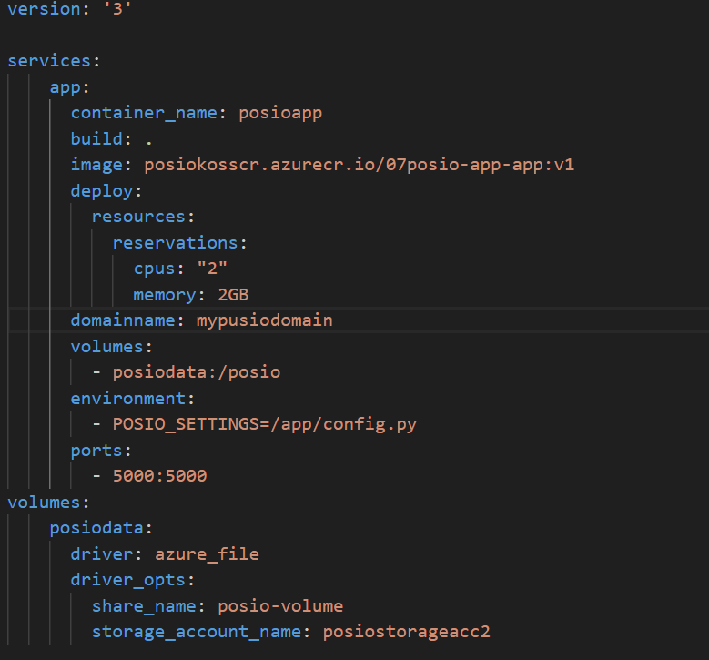

Delete image from azure container registry

az acr repository delete --name myregistry --image acr-helloworld:latest

Deploy with github repository and github action

Step 1

Create web project + database

Step 2 edit aplication

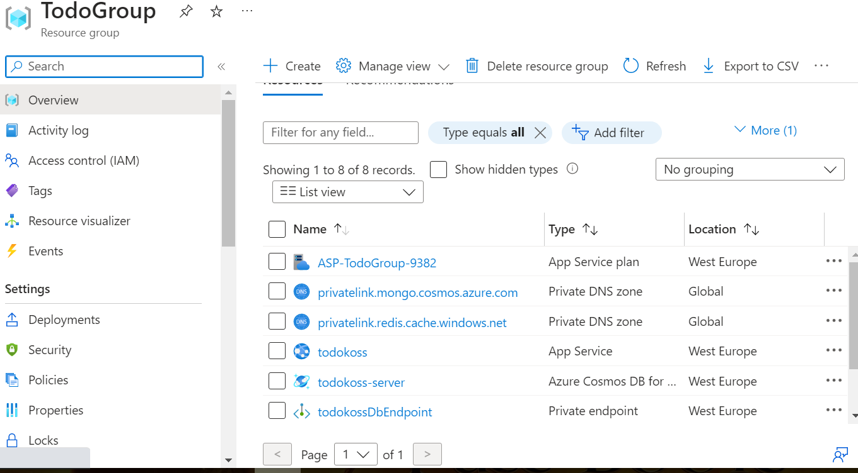

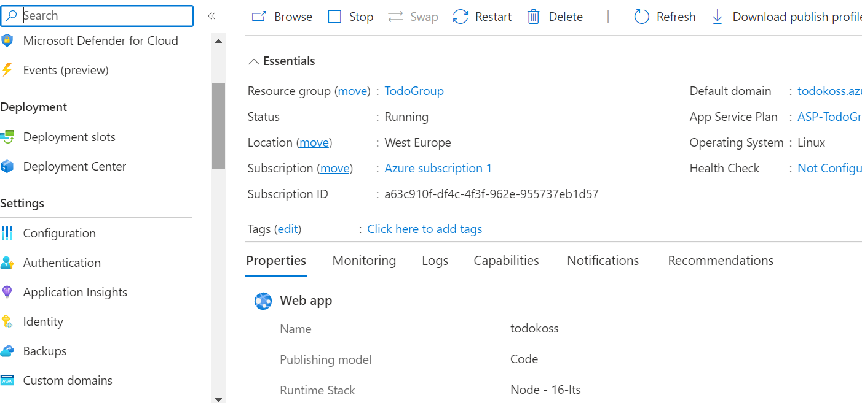

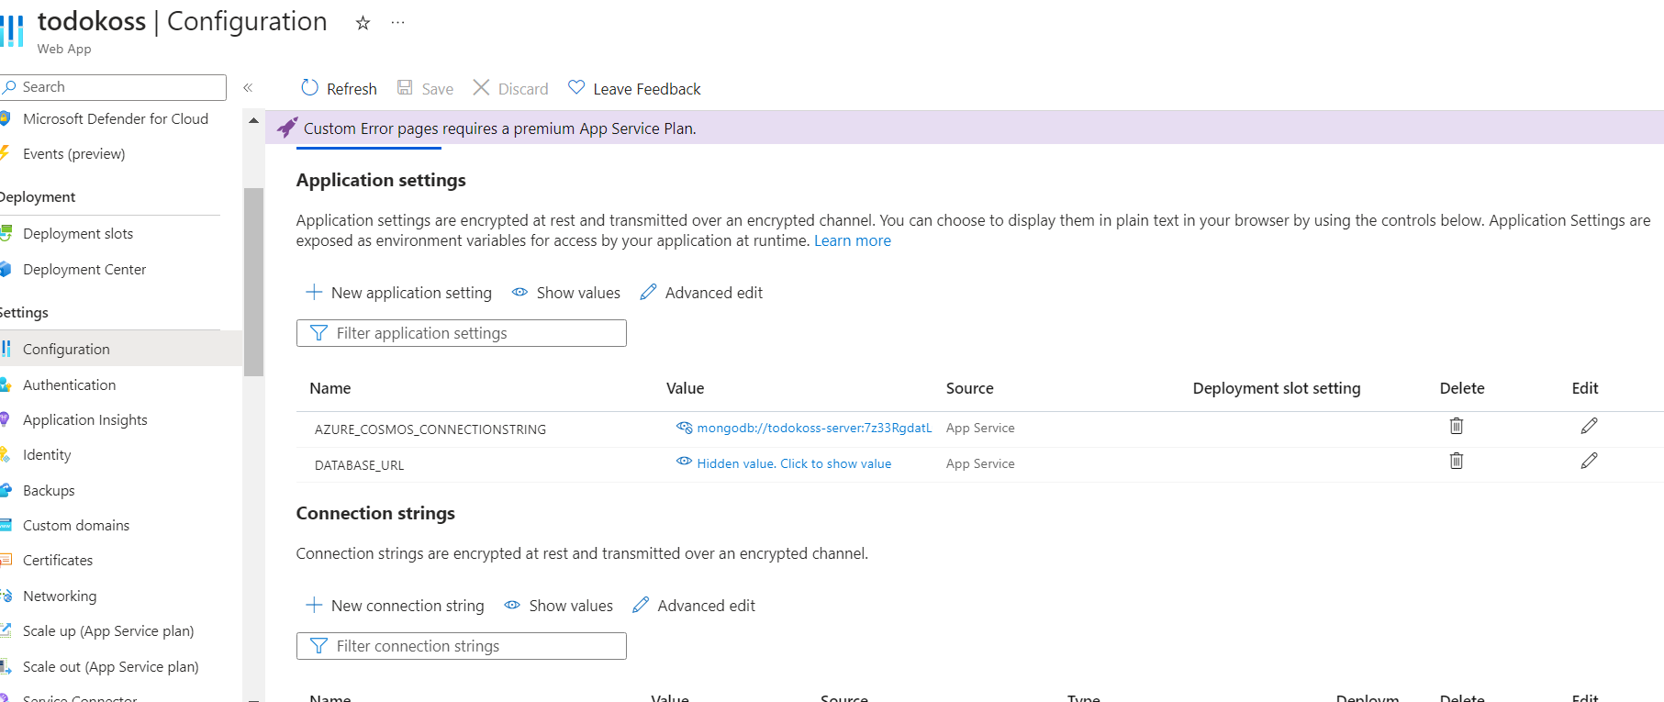

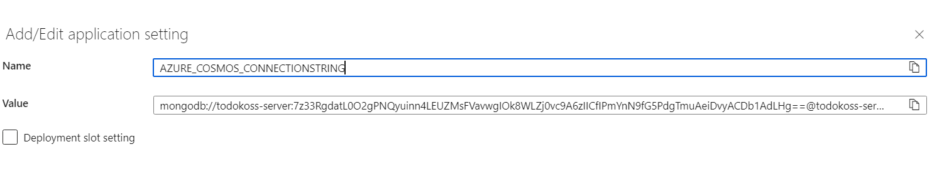

Copy value and paste in new setings



Set new name, take this from your local app ,configuration file

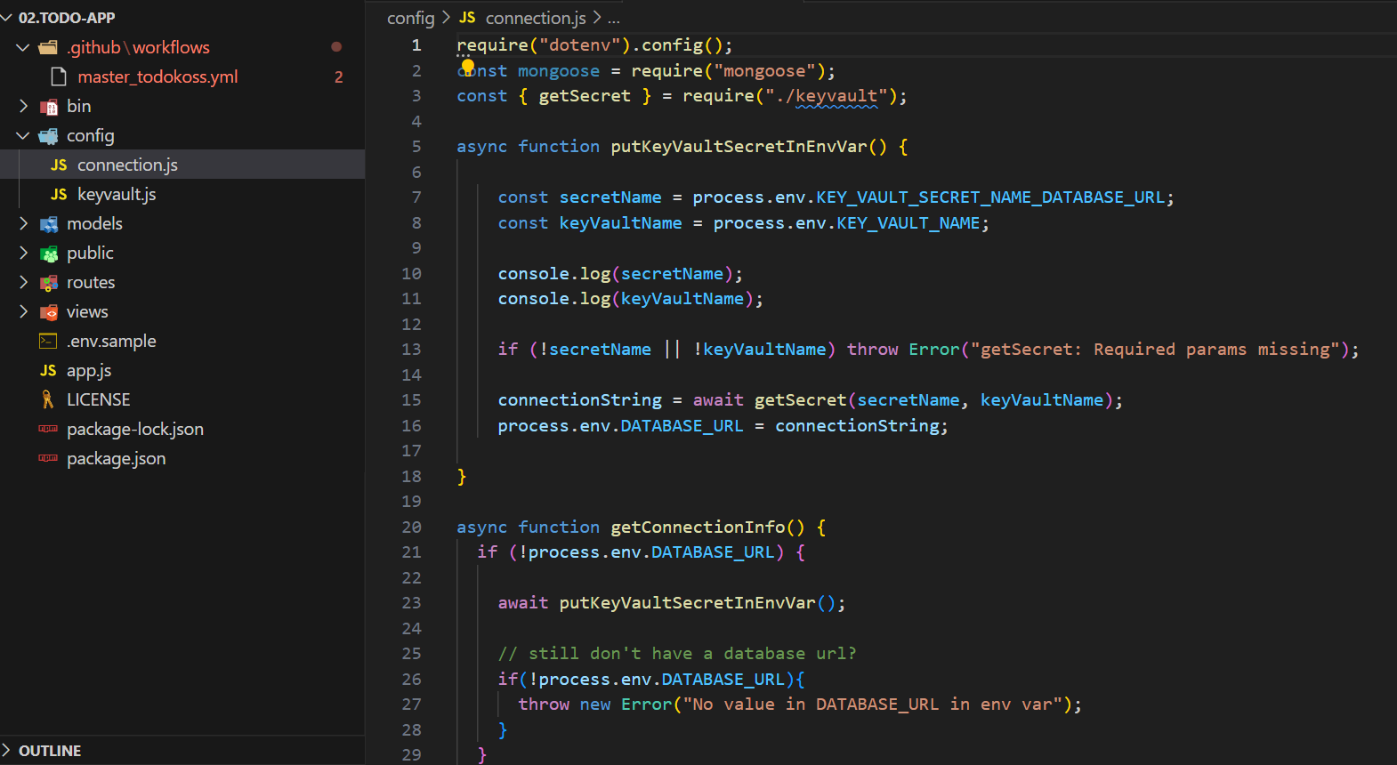

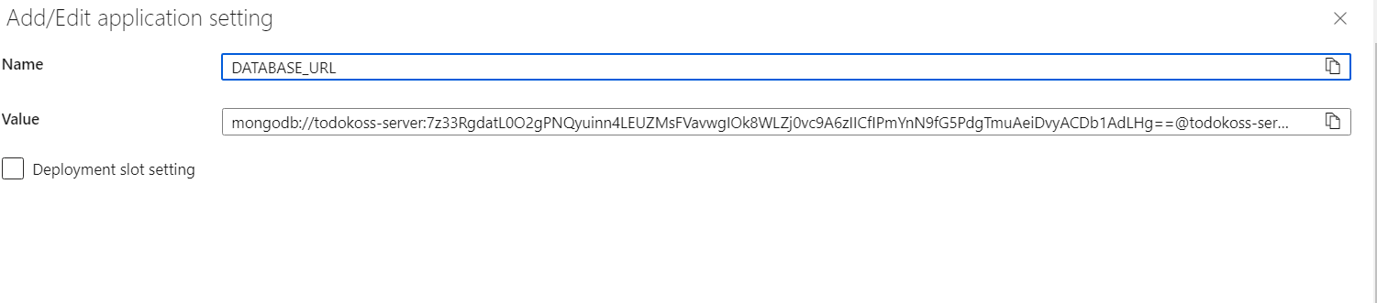

Paste value

Save setings

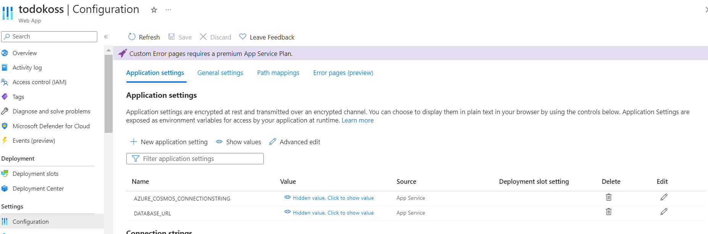

Step 3

Set git hub repo

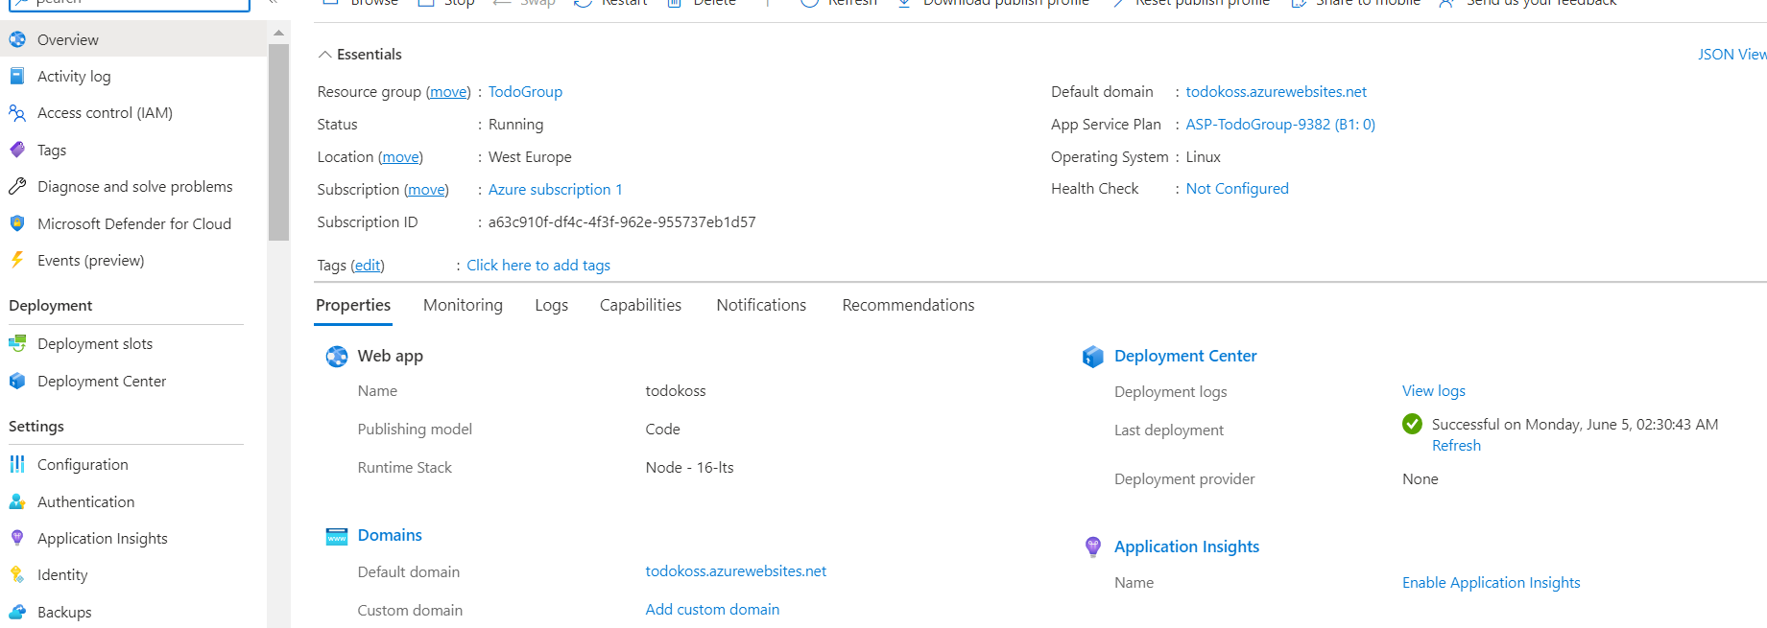

Check deployment in git hub

